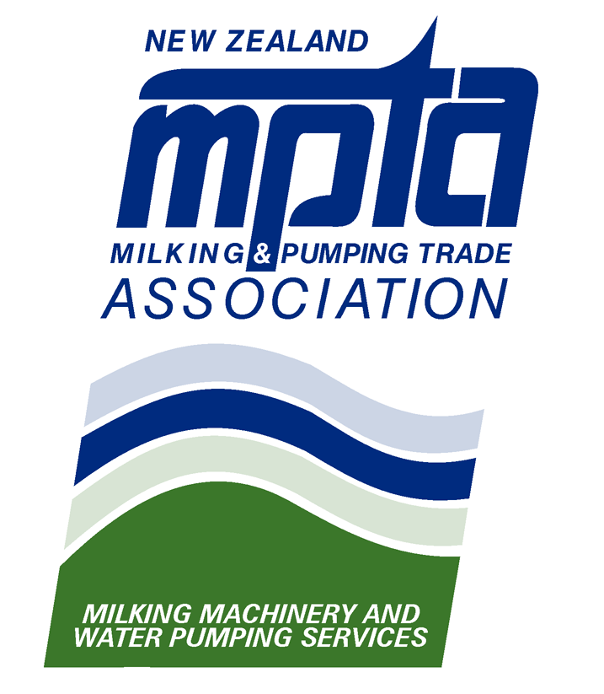
Presidents Report for the Year Ending December 2011

As NZMPTA President, I have the pleasure of reporting the year’s activities & tasks undertaken on your behalf by your elected committee.

Firstly, I would like to thank our Council Committee Members for their efforts over the past year and the time they have volunteered for the benefit of our Members. It has been a particularly busy year with plenty going on within the industry, the meetings have been getting longer and more exhausting with more agenda items requiring long discussions and time consuming follow-up between meetings. Often meetings between third parties and additional trips away are required to get the results and outcomes we think our members desire and deserve. We would achieve very little if it wasn’t for the work of the volunteer Council Members – thanks guys.

Once again, thanks to Maria Scott our Executive Officer for her efforts over the past year and for the assistance she has given me. With the workload, events, projects, legislations past and future place on the committee having an Executive Officer of Maria’s calibre is vital to the progressive operation of our organisation. Such is the workload we need to consider the employment of extra help for special projects, not just for the volume of work required, but for the expertise required for policy making, technical support, and even lobbying within political arenas to protect our Member’s interests within our industry - an industry which we, the NZMPTA Members, have grown and nurtured over 80 years.

I would also like to thank Gary Reilly, our South Island representative, for finding the time to travel from the South Island not only for our regular meetings but also attending special interest meetings as well.

Before I go further into my report I would like to thank you, our Members for your continued support. The economic situation of last few years has put pressure on a lot of businesses, times have been tough, but you still send people through for training, you pay your subs and you participate in events such as this AGM. This shows us that you value this industry, and this organisation - thank You.

The Technology Training Centre continues to be a successful arm of MPTA. Even with the numbers taking up training down due to obvious economic pressure, 16 courses were run with 122 participants receiving valuable industry training. These courses brought in an income of $108,000.00 which, after expenses, relates to a profit that is expressed as a Royalties payment to MPTA of $62,327.00. 2012 is already showing promising growth with 22 participants enrolled in the first two Milking Machine Tester’s courses for the year – this is already more than the total number of participants that went through this course in the whole of 2011.

Members Equity has grown from $189k to $219,182 in 2011.

Our membership is up on last year at 163 members with 104 current Registered Machine testers - overall our association is in pretty good health.

Let me now give you a brief report of council activity over the past year:
- 2011 saw the completion of several years’ work with Dairy NZ & Irrigation New Zealand resulting in the release of the FDE Design Code of Practice and Standards, and the development of an Accreditation Programme for FDE Designers. MPTA currently has 2 representatives sitting on the Governance Group for this programme.
- We are in the process of developing two new courses to complement FDE Design sector. These are being prepared by Dr Jim Hargreaves and will aid Members to achieve the FDE Design Standards. The first of these courses is being run next month.
- MPTA, on behalf of our Members, challenged a proposed new Code of Practice for Variable Speed Drives for which we were not consulted. Our objections resulted in a review of the proposed code being undertaken - we are awaiting the release of the amended material.
- Craig Burrows represents the MPTA on the National Mastitis Advisory Committee and has been heavily involved in the DairyNZ SmartSAMM initiative aimed at, amongst other things, fostering a united front between Dairy Professionals when dealing with Mastitis problems.
- We have, and should I say finally, acquired from Massey University the course material and lab equipment from the, now discontinued, Certificate in Agriculture Engineering course. As I mentioned earlier, we are already putting some of this material to good use by generating new courses with Jim Hargreaves.
- Unfortunately, I wish I could report the same success and progress for our Apprenticeship initiative. After a promising start, we have experienced very slow movement on this project with difficulty in getting Industry Training Organisations to pull together to achieve our desired outcome. We will continue to work towards this qualification; however, in the meantime, we will present an alternative training pathway which we will talk about later in this meeting.
- We are getting very close to completing the Employers Licence template which will be made available to Members. This allows employers who complete the standard, and live by it, to have nominated employees approved by the EWRB to undertake specific disconnect and reconnect procedures of electrical appliances.
- From the above initiative we compiled and released, at a very reasonable price, a generic Health & Safety Manual for our Members use - I’ve got mine have got yours?
- We have installed additional set-ups in the Training Centre in Palmerston North. We now have four working machines available for testing training and practice running with two of these able to be run wet - all in preparation for the new courses which have been developed. Proposed development for the installation of a water hydraulics and general pumping equipment training lab has required us to lease two garages opposite the Training Centre to house the equipment and to use as wet labs.
- A major upgrade of the Milking Machine Testing Standards, including Liner specs, was completed throughout the year. More upgrade to the Liner specs are currently being worked on and shall be released shortly.
- The MPTA Industry Survey was recently released which provided useful information to Members indicating industry norms. In addition, it gives us valuable feedback on what your training needs are. I encourage all Members to participate in the Industry Survey so that the results can be collated from a wider representation of various sectors.

The list of Registered Milking Machine Testers is held on our website and updated after every Council meeting. We are aware that there are unregistered testers practising and would like to discourage this behaviour. I urge you to promote this site to your customers, so they understand what a Registered Machine Tester is and why they should contact you to use yours. Please report any Tester’s you know of that are practising without a current registration.

Lastly, but by no means least, I would ask that that we all take a moment in thought for our Members who have suffered loss or ill-health over the past year - Philip Locke, Peter McGregor, Blake Greenfield, Peter Gallagher and any others that I have not named. We wish you guys our best and assure you our thoughts are with you.

Thanks, once again, to the Members of the MPTA Council and Maria for their work. I wish all our Members well and success for the year ahead.

Thank you for your attention.

Steve Bromley
President 27/03/12

